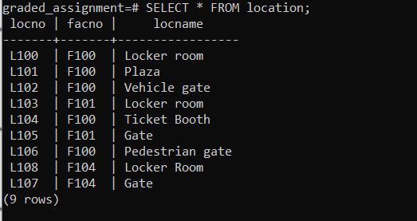

UPDATE location

SET locname = 'Gate'

WHERE locno = 'L107';